ENERGY PREDICTION FOR SOUTH CAROLINA HOUSES
In our exploration of all of our data we used 5 different models. First we explored linear regression models under 3 different categories: building infrastructure, appliance usage, and weather. In our data we decided to use 1400, or 2pm, to determine our data.
This is our summary for ourdata$month_total_electricity_usage which is what we want to predict throughout our models.
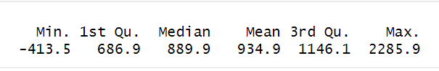

LINEAR REGRESSION MODELS
Model 1 (Building Infrastructure):
Call:
lm(formula = month_total_electricity_usage ~ ., data = train_data1)

Residuals:
Min 1Q Median 3Q Max
-877.04 -108.56 26.59 113.35 750.55

Coefficients: (2 not defined because of singularities)
Estimate Std. Error t value Pr(>|t|)
(Intercept) 1014.45341 91.72289 11.060 < 2e-16 ***
in.sqft -0.53484 0.07062 -7.574 4.56e-14 ***
in.bedrooms 17.92976 6.26761 2.861 0.00425 **
in.building_america_climate_zoneMixed-Humid -23.37012 9.07968 -2.574 0.01009 *
in.geometry_floor_area1500-1999 416.86635 37.48308 11.121 < 2e-16 ***
in.geometry_floor_area2000-2499 728.09345 71.53764 10.178 < 2e-16 ***
in.geometry_floor_area2500-2999 1032.64284 105.41474 9.796 < 2e-16 ***
in.geometry_floor_area3000-3999 1718.27908 148.72713 11.553 < 2e-16 ***
in.geometry_floor_area4000+ 4772.78521 496.54733 9.612 < 2e-16 ***
in.geometry_floor_area500-749 -147.47857 48.39780 -3.047 0.00233 **
in.geometry_floor_area750-999 NA NA NA NA
in.geometry_stories 69.00339 8.41687 8.198 3.33e-16 ***
in.geometry_wall_typeConcrete 13.10517 26.71848 0.490 0.62382
in.geometry_wall_typeSteel Frame 117.83541 51.63768 2.282 0.02255 *
in.geometry_wall_typeWood Frame -22.88752 10.44749 -2.191 0.02853 *
in.heating_setpoint60F 429.66307 40.42024 10.630 < 2e-16 ***
in.heating_setpoint65F 434.10641 22.23852 19.520 < 2e-16 ***
in.heating_setpoint67F -15.70453 40.27926 -0.390 0.69664
in.heating_setpoint68F 591.00813 16.93679 34.895 < 2e-16 ***
in.heating_setpoint70F 446.24032 17.22257 25.910 < 2e-16 ***
in.heating_setpoint72F 447.72919 17.32891 25.837 < 2e-16 ***
in.heating_setpoint75F 582.27845 17.29998 33.658 < 2e-16 ***
in.heating_setpoint76F 379.43715 23.40535 16.212 < 2e-16 ***
in.heating_setpoint78F 590.40046 26.86331 21.978 < 2e-16 ***
in.heating_setpoint80F 265.73524 27.69611 9.595 < 2e-16 ***
in.cooling_setpoint67F -359.54224 42.23176 -8.514 < 2e-16 ***
in.cooling_setpoint68F -81.57518 25.12975 -3.246 0.00118 **
in.cooling_setpoint70F -8.00208 22.18708 -0.361 0.71837
in.cooling_setpoint72F -177.51868 22.08473 -8.038 1.22e-15 ***
in.cooling_setpoint75F -209.95156 23.35479 -8.990 < 2e-16 ***
in.cooling_setpoint76F -325.46742 23.54152 -13.825 < 2e-16 ***
in.cooling_setpoint78F -234.25291 23.42337 -10.001 < 2e-16 ***
in.cooling_setpoint80F -485.20960 28.51187 -17.018 < 2e-16 ***
in.hvac_heating_typeDucted Heating -65.68780 10.87932 -6.038 1.72e-09 ***
in.hvac_heating_typeNon-Ducted Heating 211.58526 26.15355 8.090 8.01e-16 ***
in.hvac_cooling_typeHeat Pump NA NA NA NA
in.hvac_cooling_typeNone 157.87954 29.39957 5.370 8.35e-08 ***
in.hvac_cooling_typeRoom AC -348.76068 26.57522 -13.124 < 2e-16 ***
---
Signif. codes: 0 ‘***’ 0.001 ‘**’ 0.01 ‘*’ 0.05 ‘.’ 0.1 ‘ ’ 1

Residual standard error: 232.5 on 3686 degrees of freedom
Multiple R-squared: 0.6348, Adjusted R-squared: 0.6313
F-statistic: 183 on 35 and 3686 DF, p-value: < 2.2e-16

Model 1 represents variables that have to do with essential building information and see what effect that they have on the total energy usage for the month.

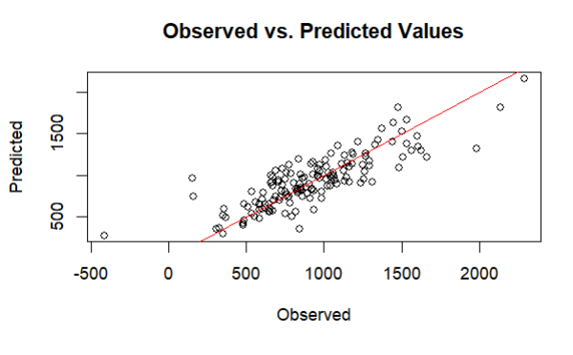
Statistical Model Analysis:
Significant Predictors:
Square Footage (in.sqft): The negative coefficient suggests that larger buildings use slightly less electricity than predicted by the model, possibly due to more efficient use of space or equipment.
Floor Area Categories: Different floor areas significantly affect electricity usage, with larger areas generally associated with higher usage.
Heating and Cooling Setpoints: The specific temperature settings for heating and cooling significantly impact predicted electricity usage. Higher setpoints in both heating and cooling lead to increased usage.
HVAC Type: Different types of heating and cooling systems (Ducted Heating, Non-Ducted Heating, Room AC) show significant differences in electricity usage, with non-ducted heating systems predicted to use more electricity.
Conclusions:

Model Fit: The model explains approximately 63.48% of the variance in electricity usage (Multiple R-squared: 0.6348), which is decent but suggests room for improvement.
Predictive Accuracy: The presence of residuals (errors in prediction) across different quartiles indicates variability in the model's accuracy across different observations

Model 2 (Appliance Usage):
Call:
lm(formula = month_total_electricity_usage ~ ., data = train_data2)

Residuals:
Min 1Q Median 3Q Max
-834.64 -82.81 -13.89 64.14 910.47

Coefficients: (16 not defined because of singularities)
Estimate Std. Error t value Pr(>|t|)
(Intercept) 226.624 8.278 27.375 < 2e-16 ***
out.electricity.clothes_dryer.energy_consumption -48.263 10.411 -4.636 3.68e-06 ***
out.electricity.clothes_washer.energy_consumption 38.669 98.399 0.393 0.694355
out.electricity.cooling_fans_pumps.energy_consumption -2102.439 354.868 -5.925 3.42e-09 ***
out.electricity.cooling.energy_consumption 402.917 25.549 15.770 < 2e-16 ***
out.electricity.dishwasher.energy_consumption -39.276 52.152 -0.753 0.451433
out.electricity.freezer.energy_consumption 336.175 123.377 2.725 0.006465 **
out.electricity.heating_fans_pumps.energy_consumption NA NA NA NA
out.electricity.heating_hp_bkup.energy_consumption NA NA NA NA
out.electricity.heating.energy_consumption NA NA NA NA
out.electricity.hot_tub_heater.energy_consumption 2573.833 11036.611 0.233 0.815612
out.electricity.hot_tub_pump.energy_consumption -1216.556 10591.774 -0.115 0.908563
out.electricity.hot_water.energy_consumption 174.829 22.605 7.734 1.33e-14 ***
out.electricity.lighting_exterior.energy_consumption 12829.899 650.160 19.733 < 2e-16 ***
out.electricity.lighting_garage.energy_consumption -762.214 981.239 -0.777 0.437334
out.electricity.lighting_interior.energy_consumption 39.248 33.726 1.164 0.244606
out.electricity.mech_vent.energy_consumption -3409.544 534.213 -6.382 1.96e-10 ***
out.electricity.plug_loads.energy_consumption 968.574 12.737 76.045 < 2e-16 ***
out.electricity.pool_heater.energy_consumption 264.514 114.082 2.319 0.020469 *
out.electricity.pool_pump.energy_consumption 558.206 18.773 29.735 < 2e-16 ***
out.electricity.pv.energy_consumption 244.985 5.114 47.902 < 2e-16 ***
out.electricity.range_oven.energy_consumption -51.507 13.238 -3.891 0.000102 ***
out.electricity.refrigerator.energy_consumption 881.735 64.290 13.715 < 2e-16 ***
out.electricity.well_pump.energy_consumption 1514.315 210.704 7.187 7.98e-13 ***
out.fuel_oil.heating_hp_bkup.energy_consumption NA NA NA NA
out.fuel_oil.heating.energy_consumption NA NA NA NA
out.fuel_oil.hot_water.energy_consumption NA NA NA NA
out.natural_gas.clothes_dryer.energy_consumption NA NA NA NA
out.natural_gas.fireplace.energy_consumption 150.171 73.220 2.051 0.040341 *
out.natural_gas.grill.energy_consumption -941.803 146.916 -6.411 1.63e-10 ***
out.natural_gas.heating_hp_bkup.energy_consumption NA NA NA NA
out.natural_gas.heating.energy_consumption NA NA NA NA
out.natural_gas.hot_tub_heater.energy_consumption 797.044 4875.289 0.163 0.870144
out.natural_gas.hot_water.energy_consumption NA NA NA NA
out.natural_gas.lighting.energy_consumption 3087.945 657.161 4.699 2.71e-06 ***
out.natural_gas.pool_heater.energy_consumption -67.873 29.385 -2.310 0.020952 *
out.natural_gas.range_oven.energy_consumption NA NA NA NA
out.propane.clothes_dryer.energy_consumption NA NA NA NA
out.propane.heating_hp_bkup.energy_consumption NA NA NA NA
out.propane.heating.energy_consumption NA NA NA NA
out.propane.hot_water.energy_consumption NA NA NA NA
out.propane.range_oven.energy_consumption NA NA NA NA
---
Signif. codes: 0 ‘***’ 0.001 ‘**’ 0.01 ‘*’ 0.05 ‘.’ 0.1 ‘ ’ 1

Residual standard error: 139.3 on 3696 degrees of freedom
Multiple R-squared: 0.8686, Adjusted R-squared: 0.8677
F-statistic: 977.4 on 25 and 3696 DF, p-value: < 2.2e-16

First Call With All Out Variables

Call:
lm(formula = month_total_electricity_usage ~ ., data = train_data2)

Residuals:
Min 1Q Median 3Q Max
-903.34 -32.76 -1.18 48.02 244.28

Coefficients:
Estimate Std. Error t value Pr(>|t|)
(Intercept) 20.40202 10.08300 2.023 0.043103 *
out.electricity.ceiling_fan.energy_consumption_total -0.11167 0.71352 -0.157 0.875639
out.electricity.clothes_dryer.energy_consumption_total -1.40807 0.30957 -4.549 5.57e-06 ***
out.electricity.clothes_washer.energy_consumption_total 28.01696 4.25203 6.589 5.05e-11 ***
out.electricity.cooling_fans_pumps.energy_consumption_total 2.87064 0.84251 3.407 0.000663 ***
out.electricity.cooling.energy_consumption_total 0.99663 0.05749 17.335 < 2e-16 ***
out.electricity.dishwasher.energy_consumption_total -5.11807 0.51211 -9.994 < 2e-16 ***
out.electricity.hot_water.energy_consumption_total 1.47016 0.23381 6.288 3.59e-10 ***
out.electricity.lighting_exterior.energy_consumption_total 0.10797 1.81385 0.060 0.952535
out.electricity.lighting_garage.energy_consumption_total 0.30706 1.13047 0.272 0.785928
out.electricity.lighting_interior.energy_consumption_total 1.15631 0.16051 7.204 7.05e-13 ***
out.electricity.plug_loads.energy_consumption_total 1.13450 0.03161 35.893 < 2e-16 ***
out.electricity.range_oven.energy_consumption_total -0.36529 0.28500 -1.282 0.200015
out.electricity.refrigerator.energy_consumption_total 0.51453 0.08401 6.125 1.00e-09 ***
out.electricity.well_pump.energy_consumption_total 0.39231 0.22647 1.732 0.083297 .
---
Signif. codes: 0 ‘***’ 0.001 ‘**’ 0.01 ‘*’ 0.05 ‘.’ 0.1 ‘ ’ 1

Residual standard error: 138.8 on 3707 degrees of freedom
Multiple R-squared: 0.8692, Adjusted R-squared: 0.8687
F-statistic: 1760 on 14 and 3707 DF, p-value: < 2.2e-16

Model 2 represents variables that have to do with application usage and see what effect that they have on the total energy usage for the month.
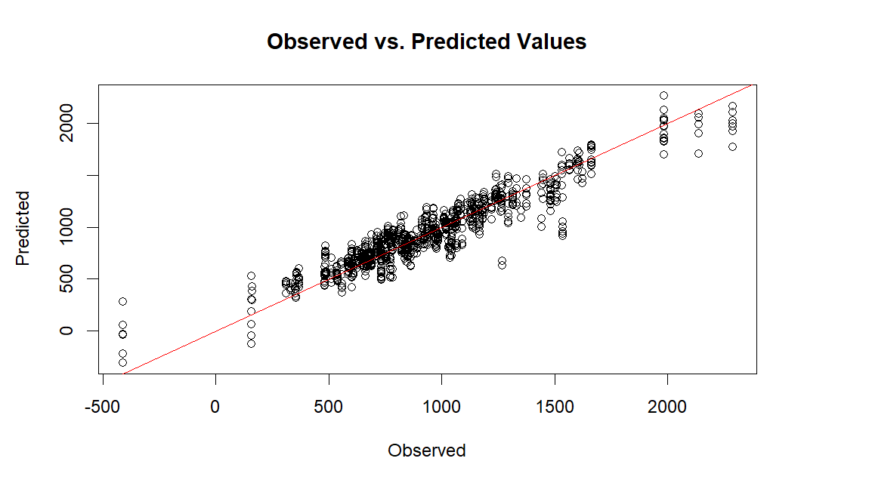
Key Takeaways from the Graph:
Linearity: The graph again shows a good linear relationship between the predicted and observed values. The data points are closely clustered around the red line, which suggests a good fit for the model.
Data Spread: Most of the data points are concentrated towards the lower end of the scale, which might indicate that the model performs well for typical or average conditions but could be less accurate at higher usage levels.

Statistical Model Analysis:
Significant Variables:
Cooling Systems: Large negative coefficients for cooling fans and pumps suggest that these appliances contribute significantly to electricity consumption when used.
Lighting: Exterior and interior lighting have a notable impact on electricity usage, with exterior lighting having a particularly high coefficient, indicating substantial energy consumption.
Plug Loads: This variable, indicating the energy consumed by plugged-in devices, has a very high positive coefficient, showing its substantial impact on overall electricity usage.
Natural Gas Appliances: Some natural gas appliances (like grills and lighting) also affect electricity usage, possibly through interactions with systems that depend on electricity for operation.

Model Fit: The model's multiple R-squared value of 0.8686 indicates that approximately 86.86% of the variance in monthly electricity usage is explained by the predictors in the model, which is an excellent level of explanatory power.

Model 3 (Weather):
Call:
lm(formula = month_total_electricity_usage ~ ., data = train_data3)

Residuals:
Min 1Q Median 3Q Max
-1337.38 -238.10 -47.41 218.48 1410.82

Coefficients:
Estimate Std. Error t value Pr(>|t|)
(Intercept) 2.009e+03 1.919e+04 0.105 0.916629
time -8.512e-07 1.252e-05 -0.068 0.945820
Dry.Bulb.Temperature...C. 1.318e+01 3.819e+00 3.450 0.000566 ***
Relative.Humidity.... -1.052e+00 7.925e-01 -1.328 0.184268
Wind.Speed..m.s. 9.861e+00 4.098e+00 2.406 0.016159 *
Wind.Direction..Deg. -7.342e-02 8.351e-02 -0.879 0.379369
Global.Horizontal.Radiation..W.m2. -1.571e+00 3.021e+00 -0.520 0.603112
Direct.Normal.Radiation..W.m2. 1.336e+00 2.890e+00 0.462 0.643843
Diffuse.Horizontal.Radiation..W.m2. 1.370e+00 3.005e+00 0.456 0.648641
---
Signif. codes: 0 ‘***’ 0.001 ‘**’ 0.01 ‘*’ 0.05 ‘.’ 0.1 ‘ ’ 1

Residual standard error: 381.5 on 3713 degrees of freedom
Multiple R-squared: 0.00972, Adjusted R-squared: 0.007586
F-statistic: 4.556 on 8 and 3713 DF, p-value: 1.549e-05

Model 3 represents variables that have to do with weather and see what effect that they have on the total energy usage for the month.

It seems that the only variable when it comes to weather that is considered statistically significant is Dry Bulb Temperature. All other variables do not contribute significantly to energy usage. Wind speed seems to have a small effect as well. Due to these factors not really contributing our R-squared becomes 0.007586 which means that 0.7586% of variance can be attributed to these factors.

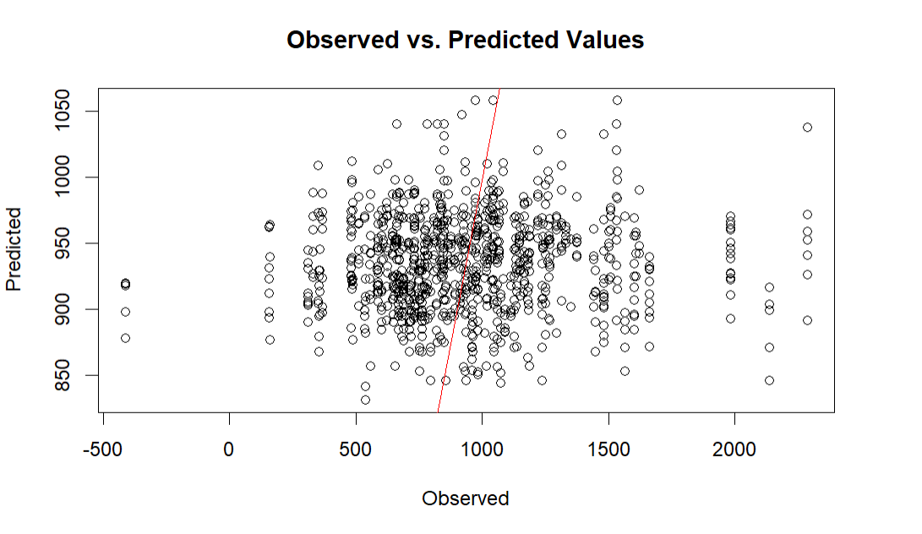
Key Takeaways from the Graph:
Scatter Plot Overview: This graph has a wide spread of points around the red line, which suggests greater prediction errors compared to the previous models. The red line is intended to show where the predicted values equal the observed values.

Prediction Accuracy: The predictions are more scattered across the graph, with a notable number of points far off the line, indicating the model's poor performance in accurately predicting values based on weather variables alone.

Statistical Model Analysis:
Model Summary: The model uses weather parameters such as temperature, humidity, wind speed, wind direction, and different types of solar radiation to predict monthly electricity usage.

Significant Predictors:
Dry Bulb Temperature (°C): Positive coefficient indicating higher temperatures lead to increased electricity usage, likely due to air conditioning and cooling systems.
Wind Speed (m/s): Another positive coefficient which could be related to more cooling needed on windy days or some other mechanical factors in buildings.

Model Effectiveness:
Low R-squared Value: The model’s R-squared value is just 0.00972, indicating that only about 0.97% of the variance in electricity usage is explained by these weather variables. This low value suggests that weather alone is not a strong predictor of monthly electricity usage in this dataset. The F-statistic suggests that while being statistically significant, the model's overall ability to predict electricity usage is limited.
Model 5 (Full Comprehensive):
Call:
lm(formula = month_total_electricity_usage ~ ., data = train_data5)

Residuals:
Min 1Q Median 3Q Max
-756.60 -47.69 -2.04 47.22 291.92

Coefficients: (17 not defined because of singularities)
Estimate Std. Error t value Pr(>|t|)
(Intercept) 3.364e+02 2.154e+01 15.621 < 2e-16 ***
in.geometry_floor_area1500-1999 5.739e+01 4.769e+00 12.033 < 2e-16 ***
in.geometry_floor_area2000-2499 7.376e+01 5.462e+00 13.504 < 2e-16 ***
in.geometry_floor_area2500-2999 8.777e+01 6.246e+00 14.051 < 2e-16 ***
in.geometry_floor_area3000-3999 2.138e+02 7.211e+00 29.647 < 2e-16 ***
in.geometry_floor_area4000+ 6.175e+02 1.255e+01 49.212 < 2e-16 ***
in.geometry_floor_area500-749 -5.053e+01 1.172e+01 -4.312 1.66e-05 ***
in.geometry_floor_area750-999 -9.480e+01 9.612e+00 -9.863 < 2e-16 ***
in.geometry_stories 2.008e+01 3.142e+00 6.390 1.87e-10 ***
in.heating_setpoint60F -1.536e+01 1.488e+01 -1.032 0.3022
in.heating_setpoint65F 1.401e+02 9.426e+00 14.864 < 2e-16 ***
in.heating_setpoint67F 1.245e+02 1.502e+01 8.291 < 2e-16 ***
in.heating_setpoint68F 1.180e+02 7.800e+00 15.130 < 2e-16 ***
in.heating_setpoint70F 9.550e+01 7.541e+00 12.665 < 2e-16 ***
in.heating_setpoint72F 7.972e+01 7.370e+00 10.818 < 2e-16 ***
in.heating_setpoint75F 1.094e+02 8.158e+00 13.406 < 2e-16 ***
in.heating_setpoint76F 5.413e+01 8.804e+00 6.148 8.66e-10 ***
in.heating_setpoint78F 6.748e+01 1.074e+01 6.285 3.66e-10 ***
in.heating_setpoint80F 4.247e+01 1.044e+01 4.068 4.85e-05 ***
in.cooling_setpoint67F -9.627e+01 1.576e+01 -6.107 1.12e-09 ***
in.cooling_setpoint68F -1.421e+02 9.081e+00 -15.648 < 2e-16 ***
in.cooling_setpoint70F -1.272e+02 8.248e+00 -15.420 < 2e-16 ***
in.cooling_setpoint72F -1.948e+02 8.291e+00 -23.495 < 2e-16 ***
in.cooling_setpoint75F -2.584e+02 8.863e+00 -29.160 < 2e-16 ***
in.cooling_setpoint76F -3.013e+02 9.007e+00 -33.457 < 2e-16 ***
in.cooling_setpoint78F -3.099e+02 8.924e+00 -34.727 < 2e-16 ***
in.cooling_setpoint80F -3.833e+02 1.091e+01 -35.122 < 2e-16 ***
in.hvac_heating_typeDucted Heating 1.421e+00 3.715e+00 0.383 0.7021
in.hvac_heating_typeNon-Ducted Heating 1.491e+01 9.862e+00 1.512 0.1306
in.hvac_cooling_typeHeat Pump NA NA NA NA
in.hvac_cooling_typeNone -1.739e+01 1.103e+01 -1.577 0.1149
in.hvac_cooling_typeRoom AC -1.675e+02 9.963e+00 -16.808 < 2e-16 ***
out.electricity.clothes_dryer.energy_consumption -3.740e+00 6.229e+00 -0.600 0.5483
out.electricity.clothes_washer.energy_consumption 2.493e+01 5.832e+01 0.427 0.6691
out.electricity.cooling_fans_pumps.energy_consumption -5.742e+02 3.075e+02 -1.868 0.0619 .
out.electricity.cooling.energy_consumption 9.161e+01 2.287e+01 4.005 6.32e-05 ***
out.electricity.dishwasher.energy_consumption -4.691e+01 3.097e+01 -1.515 0.1299
out.electricity.freezer.energy_consumption 1.507e+03 7.992e+01 18.859 < 2e-16 ***
out.electricity.heating_fans_pumps.energy_consumption NA NA NA NA
out.electricity.heating_hp_bkup.energy_consumption NA NA NA NA
out.electricity.heating.energy_consumption NA NA NA NA
out.electricity.hot_tub_heater.energy_consumption -5.771e+04 7.149e+03 -8.072 9.27e-16 ***
out.electricity.hot_tub_pump.energy_consumption 5.680e+04 6.865e+03 8.274 < 2e-16 ***
out.electricity.hot_water.energy_consumption 8.167e+01 1.351e+01 6.045 1.65e-09 ***
out.electricity.lighting_exterior.energy_consumption 1.392e+04 4.229e+02 32.907 < 2e-16 ***
out.electricity.lighting_garage.energy_consumption -4.163e+02 6.600e+02 -0.631 0.5282
out.electricity.lighting_interior.energy_consumption -1.744e+02 2.045e+01 -8.526 < 2e-16 ***
out.electricity.mech_vent.energy_consumption -2.102e+03 3.428e+02 -6.130 9.70e-10 ***
out.electricity.plug_loads.energy_consumption 9.405e+02 1.053e+01 89.304 < 2e-16 ***
out.electricity.pool_heater.energy_consumption 6.750e+02 7.803e+01 8.650 < 2e-16 ***
out.electricity.pool_pump.energy_consumption 4.860e+02 1.237e+01 39.295 < 2e-16 ***
out.electricity.pv.energy_consumption 2.418e+02 3.428e+00 70.549 < 2e-16 ***
out.electricity.range_oven.energy_consumption -2.994e+00 7.862e+00 -0.381 0.7034
out.electricity.refrigerator.energy_consumption 7.977e+02 4.101e+01 19.450 < 2e-16 ***
out.electricity.well_pump.energy_consumption 9.334e+02 1.424e+02 6.555 6.33e-11 ***
out.fuel_oil.heating_hp_bkup.energy_consumption NA NA NA NA
out.fuel_oil.heating.energy_consumption NA NA NA NA
out.fuel_oil.hot_water.energy_consumption NA NA NA NA
out.natural_gas.clothes_dryer.energy_consumption NA NA NA NA
out.natural_gas.fireplace.energy_consumption -1.901e+02 4.573e+01 -4.157 3.29e-05 ***
out.natural_gas.grill.energy_consumption -5.159e+02 9.773e+01 -5.279 1.37e-07 ***
out.natural_gas.heating_hp_bkup.energy_consumption NA NA NA NA
out.natural_gas.heating.energy_consumption NA NA NA NA
out.natural_gas.hot_tub_heater.energy_consumption -2.608e+04 3.160e+03 -8.253 < 2e-16 ***
out.natural_gas.hot_water.energy_consumption NA NA NA NA
out.natural_gas.lighting.energy_consumption 1.811e+03 4.016e+02 4.509 6.73e-06 ***
out.natural_gas.pool_heater.energy_consumption -2.151e+01 2.069e+01 -1.040 0.2986
out.natural_gas.range_oven.energy_consumption NA NA NA NA
out.propane.clothes_dryer.energy_consumption NA NA NA NA
out.propane.heating_hp_bkup.energy_consumption NA NA NA NA
out.propane.heating.energy_consumption NA NA NA NA
out.propane.hot_water.energy_consumption NA NA NA NA
out.propane.range_oven.energy_consumption NA NA NA NA
Dry.Bulb.Temperature...C. 2.808e+00 6.200e-01 4.530 6.09e-06 ***
Wind.Speed..m.s. 6.830e+00 8.846e-01 7.721 1.47e-14 ***
---
Signif. codes: 0 ‘***’ 0.001 ‘**’ 0.01 ‘*’ 0.05 ‘.’ 0.1 ‘ ’ 1

Residual standard error: 82.04 on 3664 degrees of freedom
Multiple R-squared: 0.9548, Adjusted R-squared: 0.9541
F-statistic: 1358 on 57 and 3664 DF, p-value: < 2.2e-16

Model 5 represents a comprehensive model using all of the electricity variables, temperature and wind speeds, and building specifications. This model was too much so we decided to narrow it down more by eliminating the variables that came back with NA and other variables that were not statistically significant to the model.

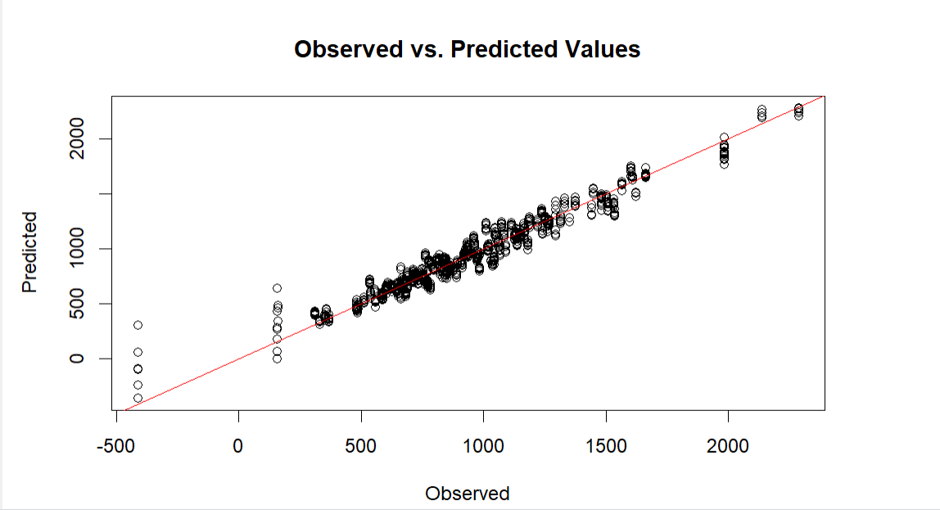
The scatter plot from your comprehensive model, Model 5, clearly shows a much tighter fit between observed and predicted values compared to the previous models, especially the one involving weather variables. This improvement is also evident in the very high R-squared value of 0.9548, suggesting that this model explains about 95.48% of the variability in electricity usage. Here's an analysis of this model and its implications:

Graph Analysis:
Scatter Plot Overview: The data points align very closely to the line of perfect prediction (the red line), indicating high accuracy in the predictions made by the model.

Data Distribution: There are fewer outliers and the data is tightly clustered around the line across the full range of observed values, suggesting consistent model performance across different scales of electricity usage.

Statistical Model Analysis:
Significant Predictors:
Floor Area: Different categories of floor area significantly impact electricity usage, with larger areas generally associated with higher usage.
Heating and Cooling Setpoints: Variations in setpoints significantly affect electricity usage, indicating the energy intensity required to maintain different indoor climates.
Appliance Usage: Specific appliances like freezers and pool pumps show significant energy consumption rates.
Weather Conditions: Variables like dry bulb temperature and wind speed are also significant, which ties the electricity usage to environmental conditions.

Model Effectiveness:
Model 5 clearly shows a much tighter fit between observed and predicted values compared to our previous models. This improvement is evident in the very high R-squared value of 0.9548, suggesting that this model explains about 95.48% of the variability in electricity usage.
Model 4 (Refined Comprehensive):
Call:
lm(formula = month_total_electricity_usage ~ ., data = train_data4)

Residuals:
Min 1Q Median 3Q Max
-699.23 -52.11 6.79 57.47 266.48

Coefficients: (1 not defined because of singularities)
Estimate Std. Error t value Pr(>|t|)
(Intercept) -130.89835 31.89489 -4.104 4.15e-05 ***
in.geometry_floor_area1500-1999 -21.05926 7.12861 -2.954 0.003155 **
in.geometry_floor_area2000-2499 -59.49792 8.97495 -6.629 3.86e-11 ***
in.geometry_floor_area2500-2999 -1.76812 10.10975 -0.175 0.861174
in.geometry_floor_area3000-3999 -32.05246 14.07684 -2.277 0.022846 *
in.geometry_floor_area4000+ -129.93423 30.25125 -4.295 1.79e-05 ***
in.geometry_floor_area500-749 116.74999 16.01404 7.290 3.76e-13 ***
in.geometry_floor_area750-999 169.45539 12.71403 13.328 < 2e-16 ***
in.geometry_stories 17.59603 4.59075 3.833 0.000129 ***
in.heating_setpoint60F -44.79257 23.07092 -1.942 0.052272 .
in.heating_setpoint65F -132.03918 16.21770 -8.142 5.28e-16 ***
in.heating_setpoint67F -271.64245 23.96741 -11.334 < 2e-16 ***
in.heating_setpoint68F -24.13912 14.74193 -1.637 0.101623
in.heating_setpoint70F -43.12599 14.39094 -2.997 0.002747 **
in.heating_setpoint72F 6.49989 14.48621 0.449 0.653678
in.heating_setpoint75F -9.79724 15.21972 -0.644 0.519797
in.heating_setpoint76F -20.77186 16.01448 -1.297 0.194689
in.heating_setpoint78F 58.06043 18.56564 3.127 0.001778 **
in.heating_setpoint80F 8.37342 17.58254 0.476 0.633935
in.cooling_setpoint67F -2.87525 24.77418 -0.116 0.907613
in.cooling_setpoint68F 51.71184 13.76004 3.758 0.000174 ***
in.cooling_setpoint70F 98.61770 12.55282 7.856 5.16e-15 ***
in.cooling_setpoint72F 154.37099 13.48147 11.451 < 2e-16 ***
in.cooling_setpoint75F 171.26240 15.10936 11.335 < 2e-16 ***
in.cooling_setpoint76F 76.07624 16.39687 4.640 3.61e-06 ***
in.cooling_setpoint78F 102.73267 15.67273 6.555 6.34e-11 ***
in.cooling_setpoint80F 75.67310 18.81075 4.023 5.87e-05 ***
in.hvac_heating_typeDucted Heating -50.28925 5.26666 -9.549 < 2e-16 ***
in.hvac_heating_typeNon-Ducted Heating 23.94414 14.43236 1.659 0.097189 .
in.hvac_cooling_typeHeat Pump NA NA NA NA
in.hvac_cooling_typeNone -192.37119 16.26520 -11.827 < 2e-16 ***
in.hvac_cooling_typeRoom AC -32.33511 16.19131 -1.997 0.045892 *
out.electricity.ceiling_fan.energy_consumption_total -0.45093 0.71978 -0.626 0.531036
out.electricity.clothes_dryer.energy_consumption_total -3.06558 0.31297 -9.795 < 2e-16 ***
out.electricity.clothes_washer.energy_consumption_total 58.38660 4.23243 13.795 < 2e-16 ***
out.electricity.cooling_fans_pumps.energy_consumption_total 4.72048 1.17732 4.009 6.21e-05 ***
out.electricity.cooling.energy_consumption_total 1.07793 0.08610 12.519 < 2e-16 ***
out.electricity.dishwasher.energy_consumption_total -6.31434 0.52250 -12.085 < 2e-16 ***
out.electricity.hot_water.energy_consumption_total 1.32066 0.24367 5.420 6.35e-08 ***
out.electricity.lighting_exterior.energy_consumption_total -11.17369 2.42705 -4.604 4.29e-06 ***
out.electricity.lighting_garage.energy_consumption_total 3.08305 1.12193 2.748 0.006025 **
out.electricity.lighting_interior.energy_consumption_total 2.08168 0.21960 9.479 < 2e-16 ***
out.electricity.plug_loads.energy_consumption_total 1.07944 0.03337 32.349 < 2e-16 ***
out.electricity.range_oven.energy_consumption_total -0.76229 0.32850 -2.321 0.020365 *
out.electricity.refrigerator.energy_consumption_total 0.66549 0.07810 8.521 < 2e-16 ***
out.electricity.well_pump.energy_consumption_total 2.35804 0.21951 10.742 < 2e-16 ***
Dry.Bulb.Temperature...C. 0.12191 0.77376 0.158 0.874812
Wind.Speed..m.s. -0.60502 1.29756 -0.466 0.641045
---
Signif. codes: 0 ‘***’ 0.001 ‘**’ 0.01 ‘*’ 0.05 ‘.’ 0.1 ‘ ’ 1

Residual standard error: 118.5 on 3675 degrees of freedom
Multiple R-squared: 0.9054, Adjusted R-squared: 0.9042
F-statistic: 764.6 on 46 and 3675 DF, p-value: < 2.2e-16

Model 4 is a version of that comprehensive model that has been refined in order to get a more accurate prediction of the total energy usage for the month. This is the model that we are going to use to predict peak demand for energy usage in July.

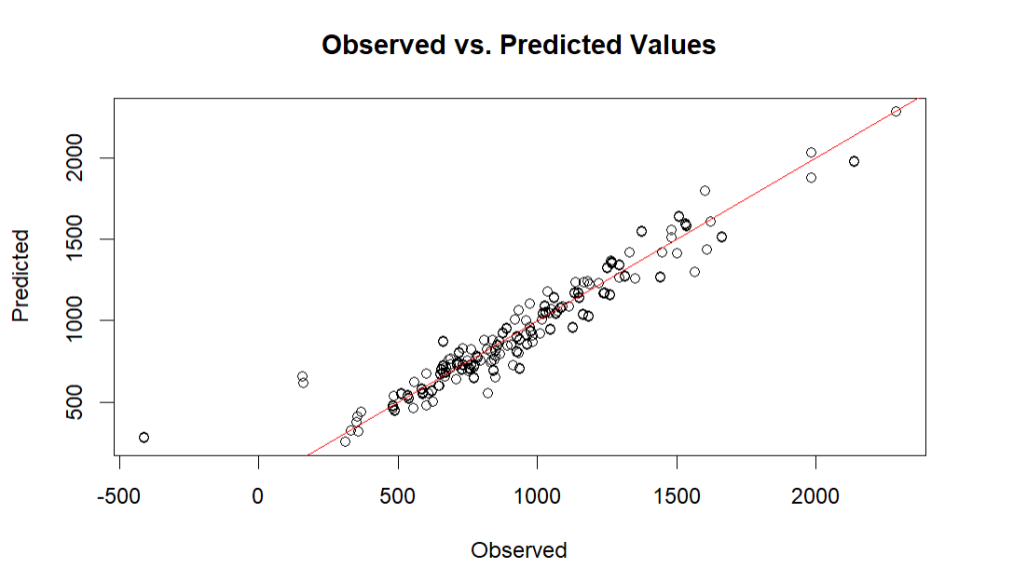
Graph Analysis:
Scatter Plot Details: The data points are closely clustered around the red line throughout the range, indicating that the model predicts electricity usage quite accurately across varying scales.
Distribution and Outliers: There appears to be a consistent distribution of prediction accuracy with a few outliers, suggesting that while the model is generally robust, there might be specific cases or conditions under which it underperforms.

Statistical Model Analysis:
Key Significant Predictors:
Floor Area: The coefficients show that smaller floor areas (500-999 sq. ft.) significantly increase predicted usage, while larger areas (2000 sq. ft. and above) tend to decrease it, possibly due to more efficient energy use in larger spaces or different types of usage patterns.
Heating and Cooling Setpoints: Varied impacts are seen with different setpoints, suggesting complex interactions between temperature management practices and electricity usage.
HVAC Types: The model identifies significant differences between ducted and non-ducted heating, as well as the lack of HVAC, which substantially impacts electricity usage.
Appliance Consumption: Each appliance's energy consumption adds a distinct amount to the electricity usage predictions, with particularly strong influences from cooling-related appliances.

Model Effectiveness:
The scatter plot from Model 4, our refined comprehensive model, also shows a strong alignment between the observed and predicted values, as evidenced by the data clustering closely to the line of perfect prediction. This suggests high accuracy in the predictions, with the model explaining approximately 90.54% of the variance in electricity usage.

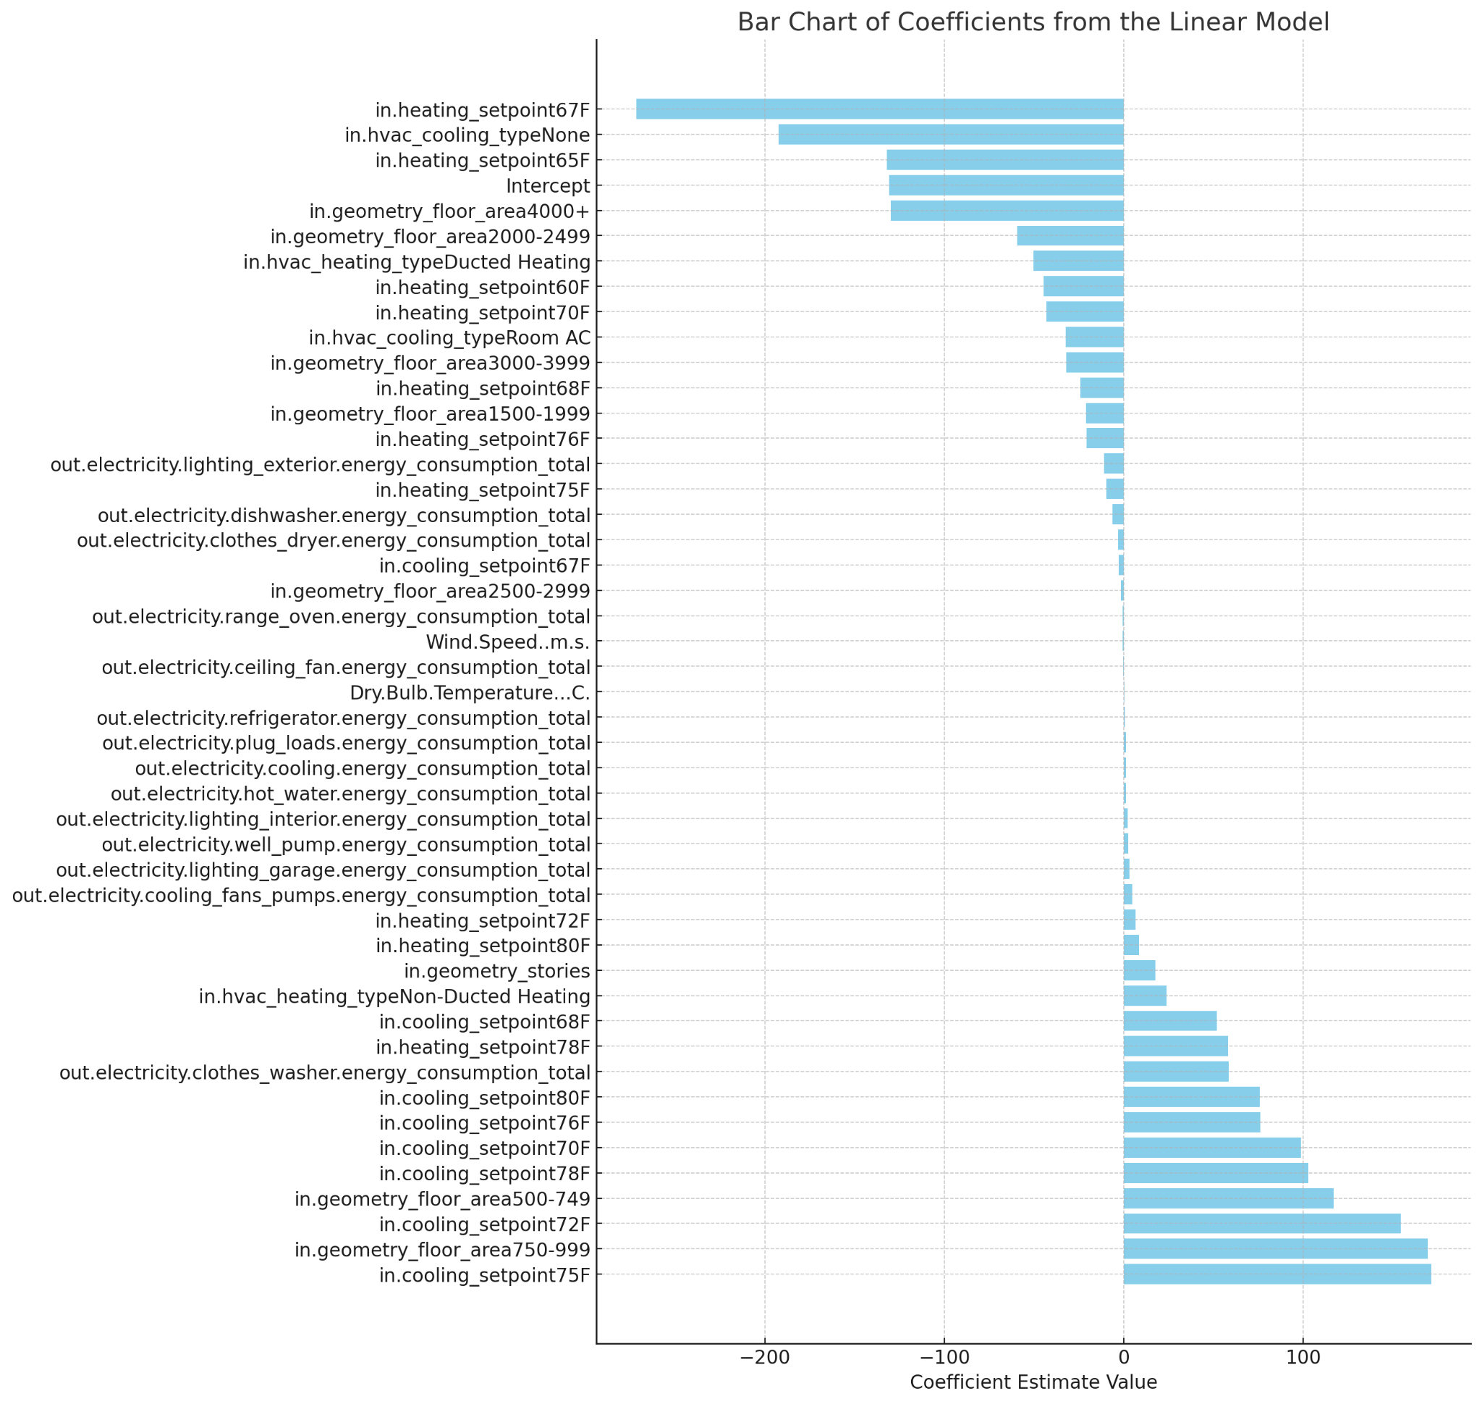
The bar chart of the coefficients from the linear model, reflecting the impact of each variable on the month_total_electricity_usage. The chart is sorted to show the smallest coefficients at the top and the largest at the bottom, with negative values extending leftward and positive values rightward. The plot provides a clear visual emphasis on each coefficient's impact. ​

Analysis of Coefficient Impacts:
Positive Influences: Variables with positive coefficients increase the predicted electricity usage. These include various cooling setpoints and specific appliance usages, which suggest that higher settings and more intensive appliance usage drive up electricity usage.

Negative Influences: Variables with negative coefficients, which decrease the predicted usage, include several heating setpoints and some floor area categories. This indicates that certain setpoints and building sizes lead to lower electricity consumption, perhaps due to more efficient heating or better insulation in larger or specifically configured buildings.

Key Variables and Their Impacts:
HVAC and Setpoints:
Cooling Setpoints: Higher cooling setpoints generally have positive coefficients, indicating an increase in electricity usage as the temperature setpoint is raised.
Heating Setpoints: Conversely, some heating setpoints have negative impacts, which could reflect energy savings from lower heating demands at certain thresholds.
Floor Area:
Smaller Areas: Certain smaller floor areas appear to have positive impacts on electricity usage, perhaps due to less efficient energy use or different lifestyle patterns.
Larger Areas: Some larger floor areas have negative coefficients, suggesting more efficient energy use or different usage patterns that lead to lower relative electricity consumption.
Appliance Usage:
Specific Appliances: The energy consumption totals for appliances like clothes washers, dishwashers, and cooling systems are significant predictors of total electricity usage, with some contributing positively and others negatively.

Practical Implications:
Energy Management: Understanding these relationships helps in managing energy more effectively, particularly by focusing on modifying setpoints and managing appliance use.
Policy and Planning: Insights from this analysis can inform building codes, energy efficiency standards, and incentives for using energy-efficient appliances.

Model 6 (RCM - 5 Degrees Hotter):
Call:
lm(formula = month_total_electricity_usage ~ ., data = train_data6)

Residuals:
Min 1Q Median 3Q Max
-699.23 -52.11 6.79 57.47 266.48

Coefficients: (1 not defined because of singularities)
Estimate Std. Error t value Pr(>|t|)
(Intercept) -131.50792 34.78954 -3.780 0.000159 ***
in.geometry_floor_area1500-1999 -21.05926 7.12861 -2.954 0.003155 **
in.geometry_floor_area2000-2499 -59.49792 8.97495 -6.629 3.86e-11 ***
in.geometry_floor_area2500-2999 -1.76812 10.10975 -0.175 0.861174
in.geometry_floor_area3000-3999 -32.05246 14.07684 -2.277 0.022846 *
in.geometry_floor_area4000+ -129.93423 30.25125 -4.295 1.79e-05 ***
in.geometry_floor_area500-749 116.74999 16.01404 7.290 3.76e-13 ***
in.geometry_floor_area750-999 169.45539 12.71403 13.328 < 2e-16 ***
in.geometry_stories 17.59603 4.59075 3.833 0.000129 ***
in.heating_setpoint60F -44.79257 23.07092 -1.942 0.052272 .
in.heating_setpoint65F -132.03918 16.21770 -8.142 5.28e-16 ***
in.heating_setpoint67F -271.64245 23.96741 -11.334 < 2e-16 ***
in.heating_setpoint68F -24.13912 14.74193 -1.637 0.101623
in.heating_setpoint70F -43.12599 14.39094 -2.997 0.002747 **
in.heating_setpoint72F 6.49989 14.48621 0.449 0.653678
in.heating_setpoint75F -9.79724 15.21972 -0.644 0.519797
in.heating_setpoint76F -20.77186 16.01448 -1.297 0.194689
in.heating_setpoint78F 58.06043 18.56564 3.127 0.001778 **
in.heating_setpoint80F 8.37342 17.58254 0.476 0.633935
in.cooling_setpoint67F -2.87525 24.77418 -0.116 0.907613
in.cooling_setpoint68F 51.71184 13.76004 3.758 0.000174 ***
in.cooling_setpoint70F 98.61770 12.55282 7.856 5.16e-15 ***
in.cooling_setpoint72F 154.37099 13.48147 11.451 < 2e-16 ***
in.cooling_setpoint75F 171.26240 15.10936 11.335 < 2e-16 ***
in.cooling_setpoint76F 76.07624 16.39687 4.640 3.61e-06 ***
in.cooling_setpoint78F 102.73267 15.67273 6.555 6.34e-11 ***
in.cooling_setpoint80F 75.67310 18.81075 4.023 5.87e-05 ***
in.hvac_heating_typeDucted Heating -50.28925 5.26666 -9.549 < 2e-16 ***
in.hvac_heating_typeNon-Ducted Heating 23.94414 14.43236 1.659 0.097189 .
in.hvac_cooling_typeHeat Pump NA NA NA NA
in.hvac_cooling_typeNone -192.37119 16.26520 -11.827 < 2e-16 ***
in.hvac_cooling_typeRoom AC -32.33511 16.19131 -1.997 0.045892 *
out.electricity.ceiling_fan.energy_consumption_total -0.45093 0.71978 -0.626 0.531036
out.electricity.clothes_dryer.energy_consumption_total -3.06558 0.31297 -9.795 < 2e-16 ***
out.electricity.clothes_washer.energy_consumption_total 58.38660 4.23243 13.795 < 2e-16 ***
out.electricity.cooling_fans_pumps.energy_consumption_total 4.72048 1.17732 4.009 6.21e-05 ***
out.electricity.cooling.energy_consumption_total 1.07793 0.08610 12.519 < 2e-16 ***
out.electricity.dishwasher.energy_consumption_total -6.31434 0.52250 -12.085 < 2e-16 ***
out.electricity.hot_water.energy_consumption_total 1.32066 0.24367 5.420 6.35e-08 ***
out.electricity.lighting_exterior.energy_consumption_total -11.17369 2.42705 -4.604 4.29e-06 ***
out.electricity.lighting_garage.energy_consumption_total 3.08305 1.12193 2.748 0.006025 **
out.electricity.lighting_interior.energy_consumption_total 2.08168 0.21960 9.479 < 2e-16 ***
out.electricity.plug_loads.energy_consumption_total 1.07944 0.03337 32.349 < 2e-16 ***
out.electricity.range_oven.energy_consumption_total -0.76229 0.32850 -2.321 0.020365 *
out.electricity.refrigerator.energy_consumption_total 0.66549 0.07810 8.521 < 2e-16 ***
out.electricity.well_pump.energy_consumption_total 2.35804 0.21951 10.742 < 2e-16 ***
Dry.Bulb.Temperature...C. 0.12191 0.77376 0.158 0.874812
Wind.Speed..m.s. -0.60502 1.29756 -0.466 0.641045
---
Signif. codes: 0 ‘***’ 0.001 ‘**’ 0.01 ‘*’ 0.05 ‘.’ 0.1 ‘ ’ 1

Residual standard error: 118.5 on 3675 degrees of freedom
Multiple R-squared: 0.9054, Adjusted R-squared: 0.9042
F-statistic: 764.6 on 46 and 3675 DF, p-value: < 2.2e-16

Model 6 is our comprehensive refined model (Model 4) using the data set that adds 5 degrees to “Dry.Bulb.Temperature”…C variable.

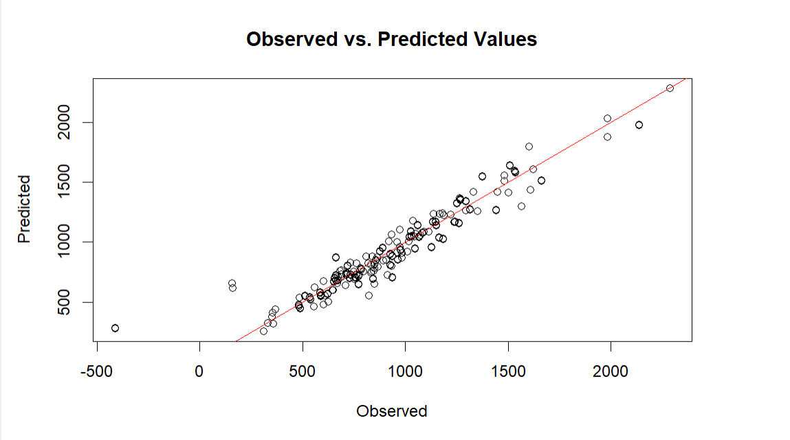

Graph Analysis:
Scatter Plot Observations: The closeness of the data points to the line of perfect prediction throughout the range of observed values suggests that the model is effectively capturing the relationship between the predictors and the electricity usage.
Prediction Distribution: There is minimal scatter away from the prediction line, indicating consistent model performance across the range of data.

Statistical Model Analysis:
Key Predictors and Their Impacts:
Floor Area Adjustments: Smaller floor areas (500-999 sq. ft.) show an increase in predicted usage, which is consistent with previous models, suggesting a higher per-square-foot energy consumption in smaller spaces.
Setpoints for Heating and Cooling: Adjustments in the setpoints significantly impact electricity usage, with cooling setpoints showing particularly strong effects, likely due to increased air conditioning loads.
HVAC Systems: The absence of an HVAC system leads to significant reductions in predicted electricity usage, while different types of heating show varied impacts.
Appliance-Specific Consumption: Individual appliances, particularly those related to cooling and washing, have substantial coefficients, reflecting their energy demands.

Model Effectiveness:
The scatter plot for Model 6 showcases excellent alignment between observed and predicted values, similarly to our previous models, indicating strong predictive accuracy. This model, like Model 4, has an impressive R-squared value of 0.9054, which confirms a high degree of variance in electricity usage explained by the predictors included in the model.

PREDICTING PEAK AND FUTURE DEMAND
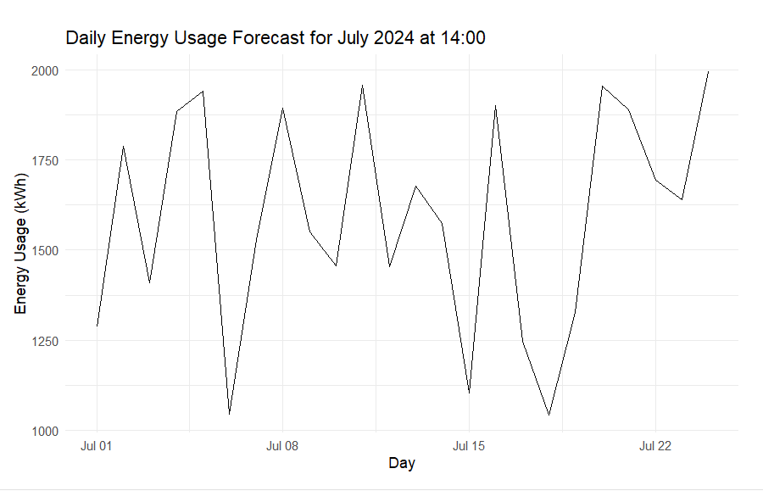

In this graph we see the predicted energy usage forJuly 2024 for the hour of 14:00. The energy usage fluctuates from day to day. We can make an educated guess that the variation in the energy usage may be due to our model’s accuracy and effectiveness.
When calculating peak energy demand using our refined comprehensive model and our data we were able to calculate that the most amount of energy used by a building in July is 2287.721 units. This occurs at the end of July somewhere between July 24-28.

